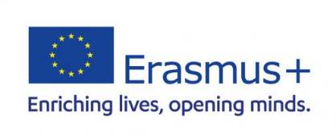
Blended Intensive Programme

CONFIRMATION LETTER

It is hereby certified by the International Relations Office that student (name and surname) ______________________________________________________________________________
from (home institution) __________________________________________________________ will receive an Erasmus+ grant for the participation in the Erasmus+ Blended Intensive Programme Sustainability in International Business hosted by the University of Maribor between 8 September and 13 September 2025 in Maribor (Slovenia).

Name of the signatory: ________________________________________

Function of the signatory: _____________________________________

Date: ___________________

Stamp and Signature:

