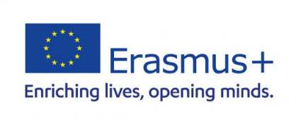
Blended Intensive Programme

CONFIRMATION LETTER

It is hereby certified by the International Relations Office that student (name and surname) ______________________________________________________________________________
from (home institution) __________________________________________________________ will receive an Erasmus+ grant for the participation in the Erasmus+ Blended Intensive Programme Corporate Governance, Strategic and Project Management for Sustainable Development hosted by the University of Maribor between 15 September and 19 September 2025 in Maribor (Slovenia).

Name of the signatory: ________________________________________

Function of the signatory: _____________________________________

Date: ___________________

Stamp and Signature:

